

Interface Control & Operational Support Document

MS_GP Integration

Table of Contents
Table of Contents 2
1. Document Control & Governance 5
2. GP Integration Overview 6
2.1 Purpose of Document 6
2.4 High-Level Architecture Summary 6
2.5 Tools & Technologies Used 7
3. Wennsoft Integration 8
3.1 Overview 8
3.1.1 System Inventory 8
3.1.2 Integration Inventory (Upstream / Downstream) 8
3.1.3 Logical Architecture Diagram 9
3.1.4 Physical Architecture Diagram 9
3.1.5 Data Flow Overview (End-to-End) 10
3.2 Wennsoft Rental Rates Integration 10
3.2.1 Integration Identification 10
3.2.2. Functional Description 10
3.2.3 Technical Design 13
3.2.4 Data Flow & Field Mapping 14
3.2.5 Error Handling & Recovery 17
3.2.9 Knowledge Management 19
3.2.10 Continuous Service Improvement (CSI) 20
3.3. WennSoft Equipment Integration 21
3.3.1 Integration Identification 21
3.3.2 Functional Description 22
3.3.3 Technical Design 25
3.3.4 Data Flow & Field Mapping 25
3.3.5 Error Handling & Recorvery 28
3.3.7 Knowledge Management 29
3.3.8 Continuous Service Improvement (CSI) 30
3.4 WennSoft Agreement Integration 32
3.4.1 Integration Identification 32
3.4.2 Functional Description 33
3.4.3 Technical Design 36
3.4.4 Data Flow & Field Mapping 36
3.4.5 Error Handling & Recovery 36
3.4.6 Knowledge Management 38
3.4.7 Continuous Service Improvement (CSI) 39
3.5.1 Integration Identification 40
3.5.2 Functional Description 40
3.5.3 Technical Design 44
3.5.4 Data Flow & Field Mapping 44
3.5.5 Error Handling & Recovery 46
3.5.6 Knowledge Management 47
3.5.7 Continuous Service Improvement (CSI) 48
3.6 WS Branches Integration 49
3.6.1 Integration Identification 49
3.6.2 Functional Description 50
Business Purpose: 50
3.6.3 Technical Design 51
3.6.4 Data Flow & Field Mapping 52
3.6.5 Error Handling & Recovery 55
3.6.6 Knowledge Management 56
3.6.7 Continuous Service Improvement (CSI) 57
3.7 WennSoft Models Integration 59
3.7.1 Integration Identification 59
3.7.2 Functional Description 59
3.7.3 Technical Design 61
3.7.4 Data Flow & Field Mapping 61
3.7.5 Error Handling & Recovery 61
3.7.6 Knowledge Management 63
3.7.7 Continuous Service Improvement (CSI) 64
3.8 EXCEL_WENNSOFT_MODELS Integration 66
3.8.1 Integration Identification 66
3.8.2 Functional Description 66
Business Purpose: 66
3.8.3 Technical Design 69
3.8.4 Data Flow & Field Mapping 69
3.8.5 Error Handling & Recovery 71
3.8.6 Knowledge Management 72
3.8.7 Continuous Service Improvement (CSI) 73
4. CMP Integrations 75
4.1 CMP_SALESREP_GP_TO_CMP Integration 75
4.1.1 Integration Identification 75
4.1.2 Functional Description 75
4.1.3 Technical Design 78
4.1.4 Data Flow & Field Mapping 79
4.1.5 Error Handling & Recovery 80
4.1.6 Knowledge Management 82
4.1.7 Continuous Service Improvement (CSI) 83
4.2 CMP_BRANCH_ORDER_STATUS_TOCMP Integration 85
4.2.1 Integration Identification 85
4.2.2 Functional Description 85
4.2.3 Technical Design 88
4.2.4 Data Flow & Field Mapping 88
4.2.5 Error Handling & Recovery 90
4.2.6 Knowledge Management 92
4.2.7 Continuous Service Improvement (CSI) 93
4.3 CMP_ITEMS_INS_UPD Integration 95
4.3.1 Integration Identification 95
4.3.2 Functional Description 95
4.3.3 Technical Design 98
4.3.4 Data Flow & Field Mapping 98
4.3.5 Error Handling & Recovery 100
4.3.6 Knowledge Management 103
4.3.7 Continuous Service Improvement (CSI) 104
4.4 CMP_BRANCH_HIRE_STATUS_TOCMP Integration 105
4.4.1 Integration Identification 105
4.4.2 Functional Description 105
4.4.3 Technical Design 109
4.4.4 Error Handling & Recovery 112
4.4.5 Knowledge Management 114
4.4.6 Continuous Service Improvement (CSI) 115
4.5 CMP_SALESREP_INACTIVATE Integration 116
4.5.1 Integration Identification 116
4.5.2 Functional Description 117
4.5.3 Technical Design 120
4.5.4 Error Handling & Recovery 123
4.5.5 Knowledge Management 125
4.5.6 Continuous Service Improvement (CSI) 126
4.6 CMP_THERAPIS Integration 127
4.6.1 Integration Identification 127
4.6.2 Functional Description 128
4.6.3 Technical Design. 131
4.6.4 Error Handling & Recovery 135
4.6.5 Knowledge Management 137
4.6.6 Continuous Service Improvement (CSI) 138
4.7 CMP_BRANCH_ORDER Integration 140
4.7.1 Integration Identification 140
4.7.2 Functional Description 140
4.7.3 Technical Design. 143
4.7.4 Error Handling & Recovery 150
4.7.5 Knowledge Management 152
4.7.6 Continuous Service Improvement (CSI) 153
4.8 CMP_CLIENTS Integration 155
4.8.1 Integration Identification 155
4.8.2 Functional Description 155
4.8.3 Technical Design. 160
6.4 Data Flow & Field Mapping 160
4.8.4 Error Handling & Recovery 165
4.8.5 Knowledge Management 167
4.8.6 Continuous Service Improvement (CSI) 168
5 CRM Integrations 170
5.1 OPAL_GP_QTE_TO_PORTAL Integration 170
5.1.1 Integration Identification 170
5.1.2 Functional Description 170
5.1.3 Technical Design. 173
5.1.4 Data Flow & Field Mapping 174
5.1.5 Error Handling & Recovery 176
5.1.6 Knowledge Management 179
5.1.7 Continuous Service Improvement (CSI) 180
5.2 OUTSYSTEMS_QUOTE Integration 181
5.2.1 Integration Identification 181
5.2.2 Functional Description 181
5.2.3 Technical Design 185
5.2.4 Error Handling & Recovery 187
5.2.5 Knowledge Management 190
5.2.6 Continuous Service Improvement (CSI) 191

1. Document Control & Governance
Item | Details
Version | 1.0
Date | 12-Feb-2026
Author | P2S
Reviewed By
Approved By
References | - Incident Management Policy  - Identity & Access Management Policy  - Change Management Policy  - ITIL processes  - Integration Inventory  - SmartConnect

2. GP Integration Overview

2.1 Purpose of Document
This document serves as the authoritative technical and operational reference for the integration ecosystem connected to Aidacare’s Microsoft Dynamics GP environment. It is designed to provide IT administrators, business stakeholders, and support teams with a centralized "Source of Truth" to ensure data integrity, facilitate rapid troubleshooting, and maintain seamless business continuity across all integrated platforms.

2.4 High-Level Architecture Summary
The integration landscape utilizes a standardized architecture where data is extracted from source systems, transformed via middleware logic to meet ERP requirements, and committed to the database through middleware. This ensures that all integrated data adheres to the core business logic and accounting rules of the organization before being finalized in the production environment.

High level architecture diagram needs to be placed
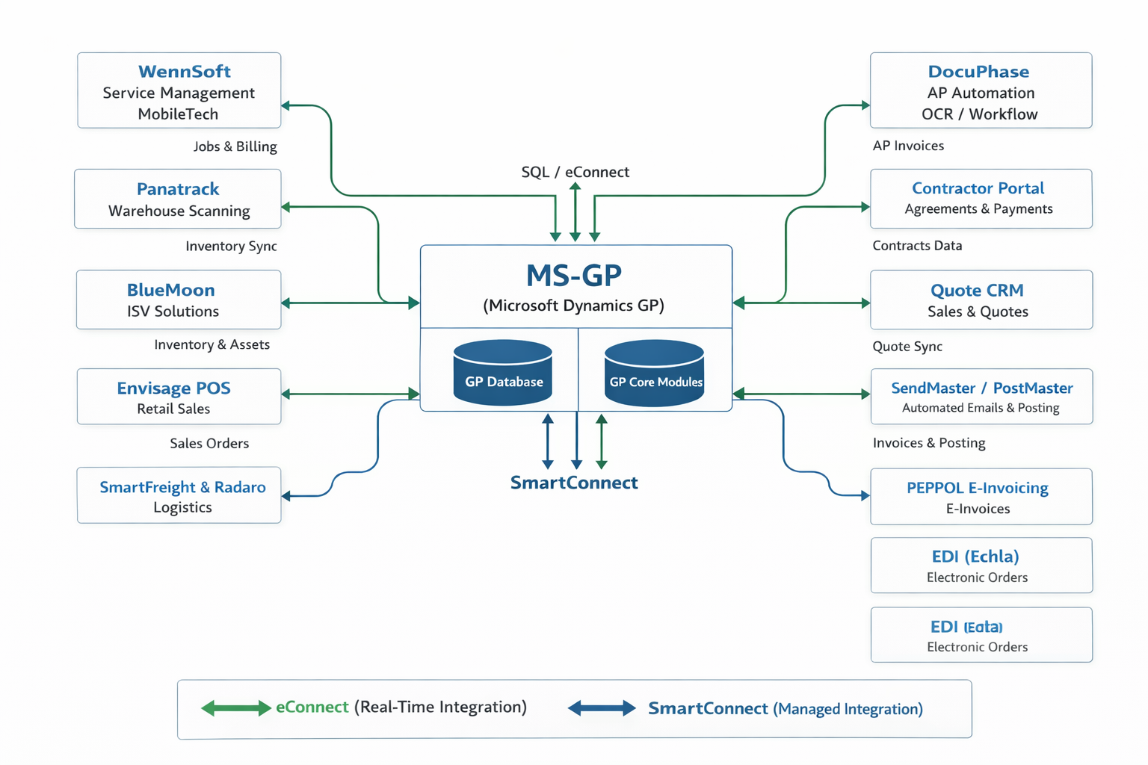

2.5 Tools & Technologies Used
- SmartConnect Core integration middleware.
- eConnect Backend GP connector used via SmartConnect.
- ODBC External system connections.
- REST & Web Services For modern API-based interactions.
- SQL Server (T-SQL / Stored Procedures) For data transformations and direct integration.
- Flat File (CSV, Excel) à File-based integrations via mapped directories.

3. Wennsoft Integration

3.1 Overview

3.1.1 System Inventory
The Aidacare service ecosystem relies on the seamless interaction between specialized operational software and the core financial engine. The primary systems involved in this landscape are:
- ERP Engine: Microsoft Dynamics GP (Great Plains).
- Service Management: Wennsoft (Key2Act) – specifically the Service Management, Job Cost, and Equipment Management modules.
- Integration Middleware: SmartConnect – used for handling external data feeds and bulk imports, eConnect for productized integration
- Database Tier: Microsoft SQL Server – hosting the TWO (or Production) and Dynamics system databases.

3.1.2 Integration Inventory (Upstream / Downstream)
This inventory captures the active data bridges within the Wennsoft ecosystem. Each entry represents a specific automated or manual flow that maintains synchronization between external data sources and the Microsoft Dynamics GP database.
- WENNSOFT_RENTAL_RATES: Updates daily rental rate structures for the equipment fleet. (Can be confirmed)
- WENNSOFT_EQUIPMENT_NEW: Imports new serialized equipment units into the master asset registry.
- WENNSOFT_AGREEMENT: Facilitates the bulk creation and renewal of service agreements for customer equipment.
- WENNSOFTMODELS: Defines an equipment model for blueprints, manufacturers, and technical classes.
- VOID_WEN_QUOTES_EQS_SOLD: Automated cleanup utility that voids open service quotes when equipment is marked as sold.
- WS_BRANCHES: Syncs branch office codes and regional service territory configurations.
- EXCEL_WENNSOFT_MODELS: Bulk update utility for administrative changes to the equipment model catalog.

3.1.3 Logical Architecture Diagram
The logical flow represents how Wennsoft sits "inside" in the Dynamics GP framework. Unlike external third-party apps, Wennsoft shares the GP dictionary and database, meaning integrations often move data from external staging areas (Excel/SQL) directly into GP-resident Wennsoft tables.

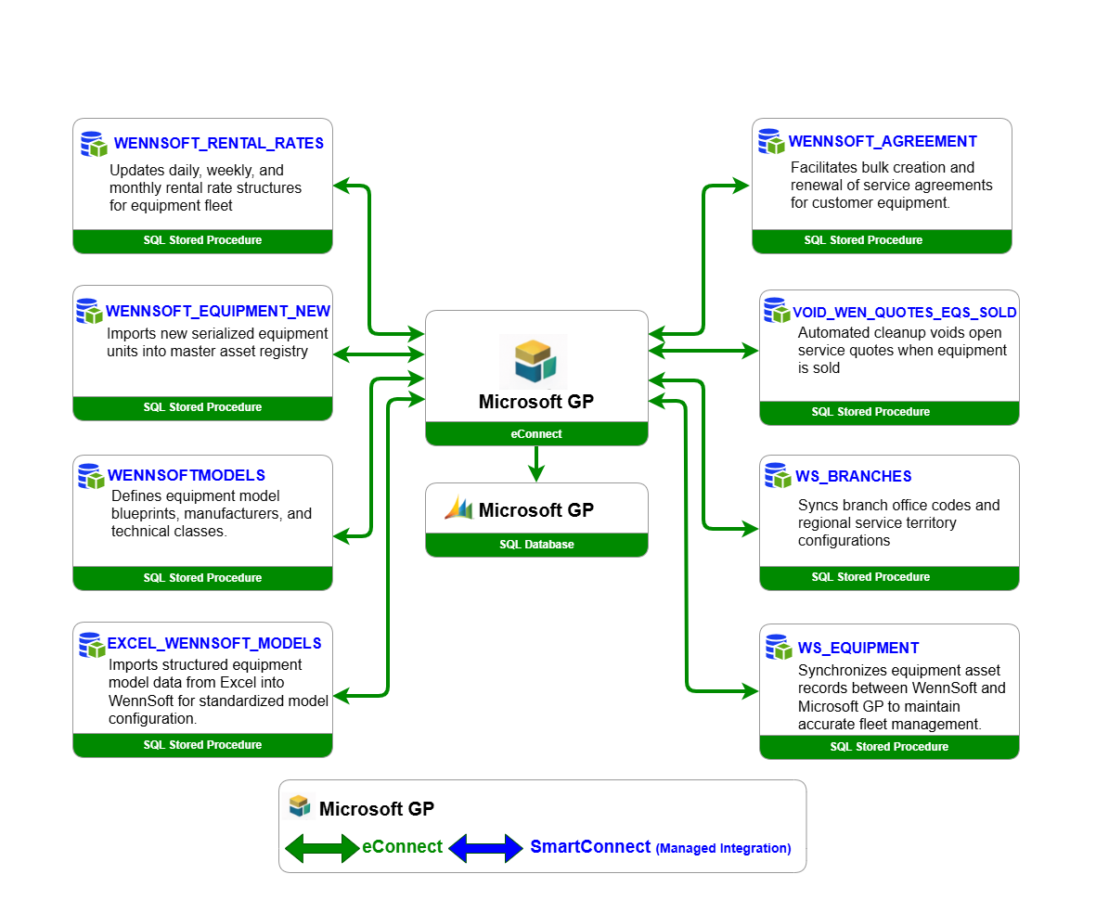

3.1.4 Physical Architecture Diagram
- Database Server: SQLPROD01 (Hosts the SQL Instance and all GP/Wennsoft physical tables).
- Application Server: GPAPP01 (Hosts the GP Client, Wennsoft Code Dictionary, and SmartConnect Windows Service).
- Connectivity: High-speed LAN/VLAN connectivity between the App server and SQL tier via Port 1433.

Also list non-prod Servers

3.1.5 Data Flow Overview (End-to-End)
- Capture: Operational data is captured in source files (Excel) or external databases.
- Transformation: Productised integration is directly through eConnect else SmartConnect retrieves the data and applies mapping rules to align source columns with GP/Wennsoft technical fields.
- Commit: Validated data is written to the physical SQL tables (e.g., WS or SV prefixed tables).
- Reporting: The data becomes visible within the GP/Wennsoft user interface for operational use.

3.2 Wennsoft Rental Rates Integration

3.2.1 Integration Identification
- Integration Name: WENNSOFT_RENTAL_RATES
- Source System: Wennsoft
- Target System: Microsoft Dynamics GP
- Direction (Inbound / Outbound / Bi-directional): Inbound (Wennsoft → Dynamics GP)
- System of Record: Wennsoft
- Business Owner: Aidacare Service/Fleet Management
- Technical Owner: Arthur Achilleos
- Criticality: High

3.2.2. Functional Description
Business Purpose:
To synchronize rental rate configurations from Wennsoft into Microsoft Dynamics GP to ensure accurate billing, project costing, and financial posting of rental transactions.

Trigger Event:
Scheduled execution via SmartConnect task scheduler.

Frequency:
Daily at 8:00 AM (Active).

Job Configuration Screenshots

SQL Server Agent Job Configuration – Rental Rate Sync
(No SQL Server Agent Job is configured for this integration.)

Integration Script Configuration
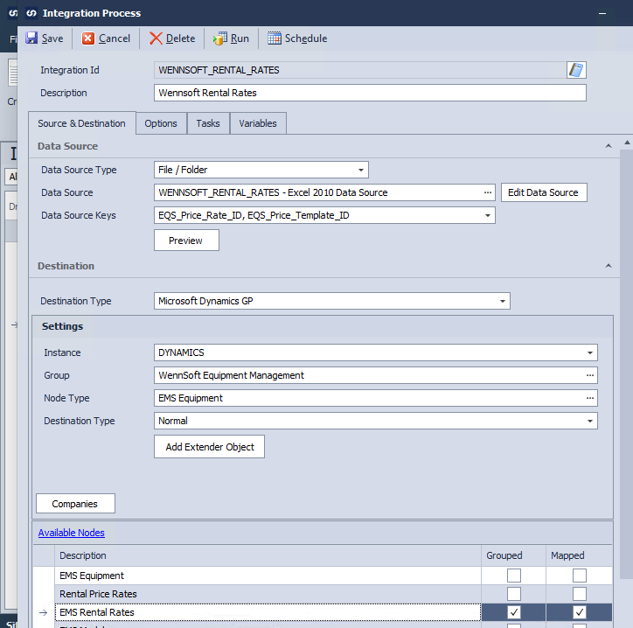

Schedule Configuration Screen
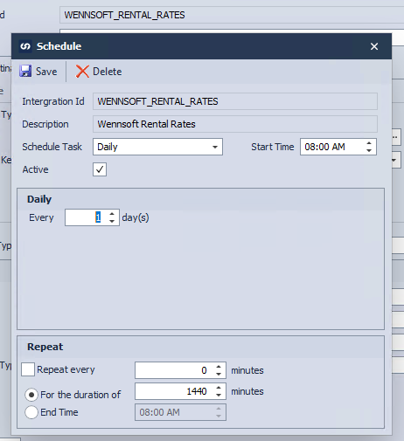

Service Account Configuration
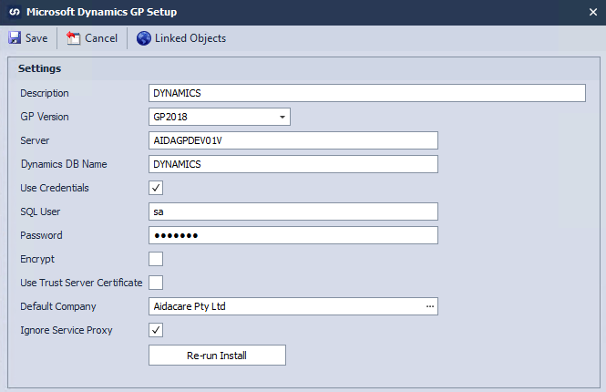
Business Rules:
Rental rates must be valid and will be imported into the GP from the file whenever this integration is executed.
Validation Rules:
Item must exist in GP.
Effective date must be valid.
At the database/server level, SQL and Windows may throw errors.
Code | Meaning
SQL 2627 | Duplicate key
SQL 547 | FK constraint
SQL Timeout | Performance issue
Login failed (18456) | Credential issue
Deadlock | Concurrency problem

Dependencies (Month-end / Period-end):
This integration updates rental rate master data and does not create financial transactions. It does not depend on GL period status or month-end close.

3.2.3 Technical Design
Integration Type (API / SSIS / SQL / File / Web Service):
File / SQL
Middleware / Tool Used:
eOne SmartConnect Desktop

Job Names / Package Names:
WENNSOFT_RENTAL_RATE
Schedules & Triggers:
Scheduled via SmartConnect
- Daily
- Every 1 day
- Start Time: 8:00 AM
- Active: Yes
Database Tables / Views Used:
Wennsoft Rental Tables
Authentication Method:
MS_GP connection configured. Encryption: Not enabled (Encrypt unchecked)
Encryption Method:
Encryption: Not enabled (Encrypt unchecked)
Logging Mechanism:
Integration Log Table with Error Capture

3.2.4 Data Flow & Field Mapping
Source Fields:
Entity | Description
CURNCYID | Currency ID applicable to the rental rate (e.g., AUD, USD).
EQS_Rental_Rate | Rental rate amount for the specified equipment pricing structure.
EQS_Price_Rate_Ord | Rental rate order/sequence number within the pricing structure.
EQS_Price_Rate_ID | Unique identifier for the rental rate definition.
EQS_Price_Template_ID | Price template identifier used to group or define pricing logic.
EQS_Rental_U_of_M | Unit of Measure applicable for rental calculation (e.g., Day, Week, Month).
Item_UOM | Base item unit of measure linked to the equipment or item.
PRCLEVEL | Price level associated with the rental rate (e.g., Standard, Contract, etc.).
EQS_Price_Rate_Type | Defines the type/category of rental rate being applied.

Below is the high-level reference mapping between Wennsoft and Microsoft Dynamics GP for Rental Rates:
Source System (Excel) | Source Field | Transformation Logic | Target System (MS_GP – EMS Rental Rates Node) | Target Field | Mandatory (Y/N)
Excel (File Source) | CURNCYID | Direct mapping | MS_GP – EMS Rental Rates | CURNCYID | Y
Excel (File Source) | EQS_Price_Template_ID | Direct mapping | MS_GP – EMS Rental Rates | EQS_Price_Template_ID | Y
Excel (File Source) | PRCLEVEL | Direct mapping | MS_GP – EMS Rental Rates | PRCLEVEL | Y
Excel (File Source) | Item_UOM | Direct mapping | MS_GP – EMS Rental Rates | Item_UOM | Y
Excel (File Source) | EQS_Rental_U_of_M | Direct mapping | MS_GP – EMS Rental Rates | EQS_Rental_U_of_M | Y
Excel (File Source) | EQS_Price_Rate_Ord | Direct mapping | MS_GP – EMS Rental Rates | EQS_Price_Rate_Ord | Y
Excel (File Source) | EQS_Rental_Rate | Direct mapping | MS_GP – EMS Rental Rates | EQS_Rental_Rate | Y
Excel (File Source) | EQS_Price_Rate_ID | Direct mapping | MS_GP – EMS Rental Rates | Rental_Price_Group (or corresponding rate ID field) | Y
Excel (File Source) | (Default / Static) | System-controlled | MS_GP – EMS Rental Rates | UpdateIfExists | System Controlled
Transformation Logic:
Rental rate data is directly transformed and transmitted from source file to Microsoft Dynamics GP without any intermediate transformation.
Target Fields:
Entity | Description
Rental_Price_Group | Identifier grouping rental pricing records under a defined rental pricing structure.
CURNCYID | Currency ID in which the rental rate is maintained (e.g., AUD).
EQS_Price_Template_ID | Price template associated with the rental rate configuration.
PRCLEVEL | Pricing level applicable to the rental rate (e.g., Standard, Contract).
Item_UOM | Base unit of measure of the equipment/item in GP.
EQS_Rental_U_of_M | Unit of measure used for rental calculation (e.g., Day, Week, Month).
EQS_Price_Rate_Ord | Sequence/order of the rental rate within the pricing template.
EQS_Rental_Rate | Actual rental rate amount stored in EMS/Wennsoft.
EQSJ4422_ALLOTY (ALLOTY) | Allocation type field used within EMS pricing logic (system-defined behavior).
UpdateIfExists | Boolean control flag indicating whether existing rental rate records should be updated if found.
Mandatory vs Optional:
- EQS_Price_Template_ID – Required to identify pricing template.
- PRCLEVEL – Required to determine price level.
- EQS_Rental_Rate – Required as the actual rental value.
- CURNCYID – Required for currency validation.
- EQS_Rental_U_of_M – Required to define rental unit (e.g., Day, Week).
- Item_UOM – Required for base item measurement context.
- EQS_Price_Rate_Ord – Required to define rate sequence within template.
Reconciliation Rules:
Rental rate records count must match between Wennsoft and GP after synchronization.
Rule | Description
High-Level Verification | Data availability is verified directly in Microsoft Dynamics GP after transformation from WennSoft.
Logging Status | Logging is not enabled in SmartConnect; therefore, no transaction-level audit trail is available.
Source Mapping Visibility | Field level mapping is specified.
Validation Controls | No automated validation, approval, or duplication checks are configured in the integration.

3.2.5 Error Handling & Recovery
Category | Description | Example
System | Infrastructure failures | SQL timeout

Common Failure Scenarios:
Database Connectivity Issue
System Exceptions:
SQL Timeout
Authentication Failure
Business Exceptions:
Inactive Rental Code
Invalid Effective Date
Retry Mechanism:
No automatic retry; failed records must be corrected and reprocessed manually in SmartConnect.
Manual Reprocessing Steps:
Re-run failed job after correcting data

Escalation Path:
Level | Responsible Team | Action
L1 | ERP Support | Review logs and reprocess
L2 | Integration Technical Owner | Investigate configuration issues
L3 | DBA / Infra | Resolve server or connectivity issues

Known Error Register
Need to work with Arthur and team

ID | Source | Priority | Error | Root Cause | Fix | Owner
KE-01 | SC |  | Item missing | Master sync gap | Create item | IT
KE-02 | GP |  | Invalid GL | Mapping error | Update mapping | Finance

Sample Logs
Logging is currently not enabled for this integration in SmartConnect but can review the activity in the SmartConnect.

3.2.9 Knowledge Management

FAQs (Frequently Asked Questions)
Q1: What happens if a rental rate does not sync to GP?
A: The transaction is logged in the integration error table and must be reviewed and reprocessed.
Q2: Can rental rates be updated directly in GP?
A: No. Wennsoft is the System of Record for rental rates. Direct updates in GP are not recommended.
Q3: How often does the integration run?
A: As per SmartConnect schedule configuration (currently set to Mannual).
Q4: Who should be contacted for urgent failures?
A: ERP Support Team / Integration Technical Team.

Known Limitations
- Integration depends on item master availability in GP.
- No automatic correction for invalid rental rate values.
- Real-time synchronization may be impacted during GP maintenance windows.
- Historical rental rate changes may not automatically back-update previous transactions.
Additional limitations:
[To Be Confirmed]

Lessons Learned
- Validation controls reduce downstream billing errors.
- Early testing during GP upgrades prevents production disruptions.
- Clear ownership between Business and Technical teams improves resolution time.
- Regular reconciliation prevents financial discrepancies.
Documented Post-Incident Learnings:
[To Be Confirmed]

Historical Incident Summary

Shadowing Observations
- Integration restart procedure documented.
- Field mapping reference maintained in Appendix.
- Step-by-step troubleshooting guide available.
- Knowledge transfer sessions conducted between team members.
- Access documentation maintained in CMDB.
Shadowing Status:
[To Be Confirmed – Completed / In Progress]
Backup Resource Identified:
[To Be Confirmed]

3.2.10 Continuous Service Improvement (CSI)

Improvement Opportunities Identified
The following improvement opportunities have been identified for the Wennsoft Rental Rates integration:
- Strengthening validation logic to reduce recurring data errors.
- Enhancing reconciliation automation between Wennsoft and GP.
- Reducing manual intervention during integration failures.
- Formalizing monthly performance review meetings.
- Improving documentation coverage for upgrade scenarios.
Additional Improvement Areas:
[To Be Confirmed]

Automation Opportunities
Potential automation enhancements include:
- Automated alert notifications on integration failure (Email / Teams).
- Auto-retry mechanism for transient or network failures.
- Automated reconciliation report generation.
- Scheduled health-check reporting dashboard.
- Automated comparison of rental rate counts between systems.
Automation Tool (if planned):
[To Be Confirmed]

Monitoring Enhancements
To enhance proactive monitoring:
- Implement real-time monitoring dashboard for integration status.
- Configure threshold-based alerts for execution delays.
- Introduce centralized log monitoring solution.
- Monitor SLA compliance metrics monthly.
Monitoring Tool Used:
[To Be Confirmed – SQL Alerts / Monitoring Platform]

Risk Reduction Plan
Key risks and mitigation actions:
Identified Risk | Mitigation Action
Data mismatch between systems | Monthly reconciliation review
Upgrade compatibility issue | Pre-upgrade regression testing
Knowledge dependency on single resource | Cross-training & documentation
Risk Review Frequency:
Quarterly
Risk Owner:
[To Be Confirmed]

Integration Health Scorecard
A quarterly Integration Health Scorecard should be maintained with the following KPIs:
KPI | Target | Current Status
Integration Success Rate | > 99% | [To Be Confirmed]
Average Incident Resolution Time | Within SLA | [To Be Confirmed]
Recurring Incident Count | Decreasing Trend | [To Be Confirmed]
Reconciliation Accuracy | 100% | [To Be Confirmed]
DR Test Compliance | 100% | [To Be Confirmed]
Scorecard Owner:
ERP / Integration Manager

3.3. WennSoft Equipment Integration

3.3.1 Integration Identification
- Integration Name: WENNSOFT_EQUIPMENT
- Source System: Microsoft Excel
- Target System: Microsoft Dynamics GP (Wennsoft / Key2Act)
- Direction: Inbound
- System of Record: Microsoft Dynamics GP
- Business Owner: Aidacare Service/Fleet Management
- Technical Owner: Arthur Achilleos
- Criticality: High

3.3.2 Functional Description

Business Purpose
The primary objective of the WENNSOFT_EQUIPMENT integration is to streamline the registration of physical assets within the Wennsoft (Key2Act) Service Management ecosystem. By automating the creation of equipment records from Excel into the ERP, Aidacare ensures that every serialized unit in the fleet is available for service dispatch, rental contract association, and maintenance history tracking. This eliminates the manual entry risk associated with high-volume asset procurement.

Trigger Event:
Scheduled execution via SmartConnect task scheduler.

Frequency:
Daily at 8:00 AM (Active).

Job Configuration Screenshots

Integration Script Configuration

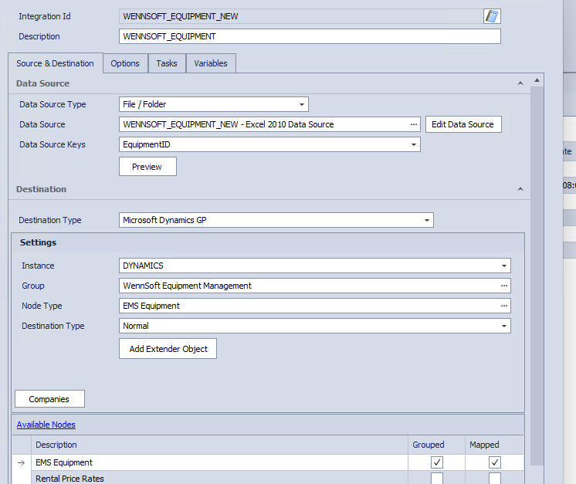

Schedule Configuration Screen
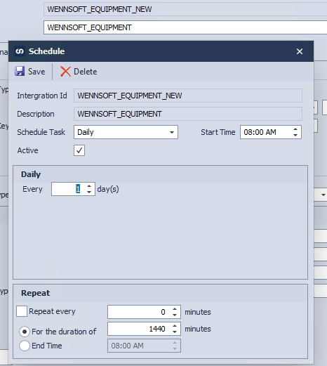

Service Account Configuration

Business Rules
- Equipment must be linked to a valid Model before synchronization.
- Only approved and finalized equipment records are transmitted to GP.
- Equipment ID / Serial Number must be unique prior to creation.
- Equipment must be created before being assigned to service, rental, or billing transactions.

Validation Rules
At the database/server level, SQL and Windows may throw errors.
Code | Meaning
SQL 2627 | Duplicate key
SQL 547 | FK constraint
SQL Timeout | Performance issue
Login failed (18456) | Credential issue
Deadlock | Concurrency problem

Dependencies (Month-end / Period-end):
This integration updates equipment master data and does not create financial transactions. It does not depend on GL period status or month-end close.

3.3.3 Technical Design
Integration Type (API / SSIS / SQL / File / Web Service):
File / SQL
Middleware / Tool Used:
eOne SmartConnect Desktop

Job Names / Package Names:
WENNSOFT_EQUIPMENT
Schedules & Triggers:
Scheduled via SmartConnect
- Daily
- Every 1 day
- Start Time: 8:00 AM
- Active: Yes

Database Tables / Views Used
- MS_GP – EMS Equipment Node (Wennsoft Service Management)
- Wennsoft Equipment Master tables (WS series – managed via eConnect node)
Authentication Method:
MS_GP connection configured. Encryption: Not enabled (Encrypt unchecked)
Encryption Method:
Encryption: Not enabled (Encrypt unchecked)
Logging Mechanism:
Integration Log Table with Error Capture

3.3.4 Data Flow & Field Mapping

Source Fields:
Entity | Description
Branch | Branch code representing the operational location associated with the equipment.
EquipmentID | Unique identifier for the equipment record in the source file.
EquipmentStatus | Status of the equipment (e.g., Available, In Service, Inactive).
EquipmentDescription | Descriptive name/details of the equipment unit.
EquipmentModel | Model identifier defining equipment specifications and manufacturer.
EquipmentCategory | Classification grouping of the equipment type.
SerialNumber | Manufacturer serial number uniquely identifying the physical unit.
Below is the high-level reference mapping between Wennsoft and Microsoft Dynamics GP for WENNSOFT_EQUIPMENT:
Source System (Excel / Source File) | Source Field | Transformation Logic | Target System (Wennsoft / GP) | Target Field | Mandatory (Y/N)
Equipment Master | EquipmentID | Direct Mapping | Wennsoft Equipment Master | EQSEquipmentID | Y
Equipment Master | EquipmentModel | Validate existence in Model Master | Wennsoft Equipment Master | EQSEQUIPMODEL | Y
Equipment Master | EquipmentCategory | Direct Mapping | Wennsoft Equipment Master | EQSEquipmentCategory | Y
Equipment Master | Branch | Direct Mapping | Wennsoft Equipment Master | EquipmentBranch | Y
Equipment Master | Branch | Division Derivation / Mapping Rule | Wennsoft Equipment Master | EquipmentDivision | Y

Transformation Logic
Equipment data is directly transformed and transmitted from WennSoft to Microsoft Dynamics GP without any intermediate transformation.

Target Fields

Entity | Description
EQSEquipmentID | Unique identifier for the equipment record stored in the Wennsoft Equipment Master.
EQSEQUIPMODEL | Equipment model reference linking the unit to the Model Master record in Wennsoft.
EQSEquipmentCategory | Classification category assigned to the equipment within Wennsoft.
EquipmentDivision | Organizational division associated with the equipment record.
EquipmentBranch | Branch/location code where the equipment is registered or assigned.

Mandatory vs Optional
- EQSEquipmentID – Must be provided and unique.
- EQSEQUIPMODEL – Must exist in the Wennsoft Model Master.
- EQSEquipmentCategory – Required for proper classification and reporting.
- EquipmentBranch – Required to associate the equipment with an operational branch.
- EquipmentDivision – Required for organizational/financial segmentation.

Reconciliation Rules
- Uniqueness Check: The system verifies that the Equipment ID or Serial Number is unique before committing the record to the database.
- Existence Validation: The Customer ID provided in the source must already exist in the Microsoft Dynamics GP Customer Master table (RM00101), where applicable.
- Value Constraints: Numeric fields such as cost, quantity, or acquisition value must be greater than or equal to zero (≥ 0).

3.3.5 Error Handling & Recorvery
Category | Description | Example
Data Validation | Invalid or missing data | Item not found in GP
System | Infrastructure failures | SQL timeout
Integration | Job execution failure | SmartConnect map failed
Security | Access failure | Credential expired
Common Failure Scenarios:
Database Connectivity Issue
System Exceptions:
SQL Timeout
Authentication Failure
Retry Mechanism:
No automatic retry; failed records must be corrected and reprocessed manually in SmartConnect.
Manual Reprocessing Steps:
Re-run failed job after correcting data

Escalation Path:
Level | Responsible Team | Action
L1 | ERP Support | Review logs and reprocess
L2 | Integration Technical Owner | Investigate configuration issues
L3 | DBA / Infra | Resolve server or connectivity issues

Known Error Register
Need to work with Arthur and team

ID | Source | Priority | Error | Root Cause | Fix | Owner
KE-01 | SC |  | Item missing | Master sync gap | Create item | IT
KE-02 | GP |  | Invalid GL | Mapping error | Update mapping | Finance

Sample Logs
Logging is currently not enabled for this integration in SmartConnect but can review the activity in the SmartConnect.

3.3.7 Knowledge Management

FAQs (Frequently Asked Questions)
Q1: What happens if an equipment record fails to import into GP/Wennsoft?
A: The failed transaction is logged in the integration error log (SmartConnect / SQL log), and the record must be reviewed, corrected in the source file, and reprocessed.
Q2: Can equipment records be created directly in GP/Wennsoft instead of using the integration?
A: Yes, equipment can be manually created in Wennsoft; however, for bulk onboarding and consistency, the integration process is the recommended method.
Q3: How often does the equipment integration run?
A: The integration runs on-demand or as per scheduled configuration (if SQL Agent job is enabled).
Q4: What is the most common reason for equipment import failure?
A: Common reasons include missing Model ID in the Model Master, duplicate Equipment ID, invalid Customer/Branch code, or data type validation errors.[To Be Confirmed – Contact Details]

Known Limitations
- Equipment record creation depends on prior availability of valid Model Master records.
- The integration does not automatically create missing Model IDs or Branch codes.
- Duplicate Equipment IDs are rejected and must be manually corrected.
- If SQL Job or SmartConnect service fails during execution, manual restart may be required.
- Real-time synchronization may not be available during GP maintenance windows.

Lessons Learned
- Validating Model Master and Branch codes before execution significantly reduces rejection rates.
- Enforcing unique Equipment ID checks prevents duplicate asset tracking.
- Pre-validation of source files improves batch processing success rate.
- Clear ownership between Fleet Management and IT reduces resolution time.
Documented Post-Incident Learnings:
[To Be Confirmed]

Historical Incident Summary

Date | Incident Description | Severity | Root Cause | Resolution
[To Be Confirmed] | Equipment import failure | P2 | Model ID missing | Model created and job re-run
[To Be Confirmed] | Duplicate Equipment ID error | P3 | Duplicate serial entry in source | Source corrected and reprocessed
Full Incident Register Reference:
Zendesk / Central Integration Register

Shadowing Observations
To reduce key-person dependency risk:
- Equipment integration execution steps are documented.
- Field mapping reference maintained in Appendix.
- Step-by-step troubleshooting guide available.
- Knowledge transfer sessions conducted between Integration and ERP teams.
- Access credentials and configuration details documented in CMDB.

3.3.8 Continuous Service Improvement (CSI)

Improvement Opportunities Identified
The following improvement opportunities have been identified for the Wennsoft Equipment integration:
- Strengthening validation logic to reduce recurring equipment data errors.
- Enhancing pre-import validation for Model ID, Branch, and Equipment ID uniqueness.
- Reducing manual intervention during bulk equipment onboarding.
- Formalizing monthly performance review meetings for equipment data accuracy.
- Improving documentation coverage for asset lifecycle scenarios (commissioning, decommissioning, transfer).
Additional Improvement Areas: [To Be Confirmed]

Automation Opportunities
Potential automation enhancements include:
- Automated alert notifications on equipment integration failure (Email / Teams).
- Auto-retry mechanism for transient or network-related failures.
- Automated duplicate Equipment ID detection prior to database commit.
Automation Tool (if planned): [To Be Confirmed]

Monitoring Enhancements
To enhance proactive monitoring:
- Implement real-time monitoring dashboard for equipment integration status.
- Configure threshold-based alerts for execution delays or abnormal failure rates.
- Introduce centralized log monitoring solution for SmartConnect / SQL logs.
Monitoring Tool Used:
[To Be Confirmed – SQL Alerts / Monitoring Platform]

Risk Reduction Plan
Key risks and mitigation actions:
Identified Risk | Mitigation Action
Duplicate Equipment ID creation | Enforce uniqueness validation before commit
Missing Model Master dependency | Pre-validation against Model table
Data mismatch between source and GP | Batch reconciliation review after each run
Integration failure during bulk onboarding | Controlled batch size processing
Risk Review Frequency:
Quarterly

Integration Health Scorecard
A quarterly Integration Health Scorecard should be maintained with the following KPIs:
KPI | Target | Current Status
Integration Success Rate | > 99% | [To Be Confirmed]
Average Incident Resolution Time | Within SLA | [To Be Confirmed]
Recurring Incident Count | Decreasing Trend | [To Be Confirmed]
Equipment Record Accuracy | 100% | [To Be Confirmed]
DR Test Compliance | 100% | [To Be Confirmed]
Scorecard Owner:
ERP / Integration Manager

3.4 WennSoft Agreement Integration

3.4.1 Integration Identification
- Integration Name: WENNSOFT_AGREEMENT
- Source System: Microsoft Excel (File / Folder – Excel 2010 Data Source)
- Target System: Microsoft Dynamics GP (WennSoft / Key2Act – Equipment Management)
- Direction (Inbound / Outbound / Bi-directional): Inbound (Excel → Dynamics GP)
- System of Record: Wennsoft
- Business Owner: Aidacare Service/Fleet Management
- Technical Owner: Arthur Achilleos
- Criticality (High / Medium / Low): High

3.4.2 Functional Description

Business Purpose:
To automate the creation and maintenance of Rental Agreement Header records within WennSoft (Key2Act) Equipment Management by importing structured agreement data from Excel into Microsoft Dynamics GP, ensuring consistency, reducing manual entry, and supporting rental billing and asset lifecycle management processes.

Trigger Event:
Scheduled execution via SmartConnect (Daily schedule configured at 08:00 AM).

Frequency:
Daily (Every 1 day).

Job Configuration Screenshots

Integration Script Configuration
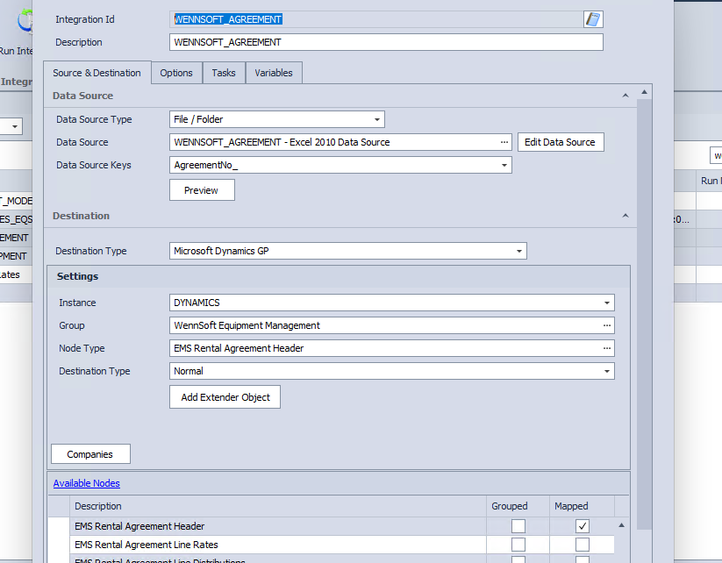

Schedule Configuration Screen
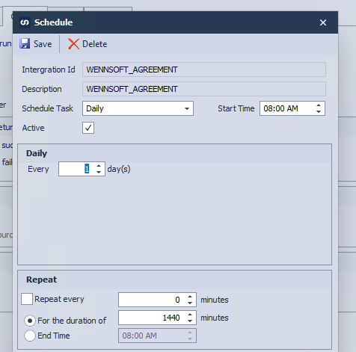

Service Account Configuration

Business Rules:
- Agreement Number must be unique within the system.
- Customer ID must exist in the GP Customer Master.
- Branch and Division must be valid within the organizational structure.
- Agreement dates must fall within an open financial period.

Validation Rules: (To be confirmed as unable to open configurations in smartConnect)
- Mandatory fields must not be blank (e.g., Agreement Number, Customer ID, Start Date).
- Date fields must follow valid date format.
- Customer must exist in RM00101 (Customer Master).
At the database/server level, SQL and Windows may throw errors.
Code | Meaning
SQL 2627 | Duplicate key
SQL 547 | FK constraint
SQL Timeout | Performance issue
Login failed (18456) | Credential issue
Deadlock | Concurrency problem

Dependencies (Month-end / Period-end):
Agreement creation should not occur in closed financial periods.

3.4.3 Technical Design

Integration Type (API / SSIS / SQL / File / Web Service):
File-based integration using Excel as the source with SmartConnect processing.

Middleware / Tool Used:
eOne SmartConnect.

Job Names / Package Names:
WENNSOFT_AGREEMENT (SmartConnect Map).

Schedules & Triggers:
Configured in SmartConnect Scheduler – Daily execution at 08:00 AM.

Database Tables / Views Used:
GP Agreement Tables
Authentication Method:
MS_GP connection configured. Encryption: Not enabled (Encrypt unchecked)
Encryption Method:
Encryption: Not enabled (Encrypt unchecked)

Logging Mechanism:
SmartConnect Execution History with error capture and record-level validation logging.

3.4.4 Data Flow & Field Mapping
(Not able to connect to the SmartConnect mappings)

3.4.5 Error Handling & Recovery

Category | Description | Example
Data Validation | Invalid or missing data | Item not found in GP
System | Infrastructure failures | SQL timeout
Integration | Job execution failure | SmartConnect map failed
Security | Access failure | Credential expired

Common Failure Scenarios:
- Duplicate Agreement Number already existing in GP.
- Missing or invalid Customer ID in source file.
- Invalid or missing mandatory fields (Agreement No / Start Date / Branch).
System Exceptions:
- SQL connectivity failure or timeout.
- SmartConnect service or scheduler not running.
- Authentication failure (service account / GP login).
Business Exceptions:
- Agreement created in a closed financial period.
- Invalid or inactive Customer record in GP.
- Invalid Branch or Division code.
Retry Mechanism:
No automatic retry; failed records must be corrected and reprocessed manually in SmartConnect.
Manual Reprocessing Steps:
Re-run failed job after correcting data

Escalation Path:
Level | Responsible Team | Action
L1 | ERP Support | Review logs and reprocess
L2 | Integration Technical Owner | Investigate configuration issues
L3 | DBA / Infra | Resolve server or connectivity issues

Known Error Register
Need to work with Arthur and team

ID | Source | Priority | Error | Root Cause | Fix | Owner
KE-01 | SC |  | Item missing | Master sync gap | Create item | IT
KE-02 | GP |  | Invalid GL | Mapping error | Update mapping | Finance

Sample Logs
Logging is currently not enabled for this integration in SmartConnect but can review the activity in the SmartConnect.

3.4.6 Knowledge Management

FAQs (Frequently Asked Questions)
Q1: What happens if an agreement fails to import?
A: The failed record is logged in SmartConnect History and must be corrected in the source file before reprocessing.
Q2: Can agreements be created directly in GP/WennSoft?
A: Yes, agreements can be manually created in GP; however, bulk creation should be performed through the integration for consistency.
Q3: How often does the agreement integration run?
A: As per SmartConnect schedule configuration (currently set to Daily).

Known Limitations
- Integration depends on valid Customer, Branch, and Division setup in GP.
- No automatic retry for failed agreement records.
- Real-time processing is not supported; execution is schedule-based.

Lessons Learned
- Pre-validation of source data reduces rejection rates.
- Ensuring master data availability (Customer/Branch) prevents downstream errors.
- Clear ownership between Business and IT improves resolution time.

- Documented Post-Incident Learnings:
[To Be Confirmed]

Historical Incident Summary

Shadowing Observations
- Integration execution steps documented.
- Field mapping maintained in Appendix.
- Troubleshooting steps available for common failures.
Shadowing Status:
[To Be Confirmed – Completed / In Progress]
Backup Resource Identified:
[To Be Confirmed]

3.4.7 Continuous Service Improvement (CSI)

Improvement Opportunities Identified
- Strengthen validation rules to reduce agreement rejection rates.
- Implement pre-import data validation checks for Customer and Branch codes.
- Improve documentation of agreement lifecycle scenarios (creation, renewal, cancellation).

Automation Opportunities
- Configure automated email notifications on integration failure.
- Implement pre-validation script to detect duplicate Agreement Numbers before import.
- Develop automated reconciliation report comparing source vs created agreements.
Automation Tool (if planned): [To Be Confirmed]

Monitoring Enhancements

Risk Reduction Plan
Identified Risk | Mitigation Action
Duplicate Agreement creation | Enforce uniqueness validation before commit
Missing master data dependency | Pre-validation against GP master tables
Job failure during execution | Scheduled monitoring and alert notification
Risk Review Frequency: Quarterly

Integration Health Scorecard
KPI | Target | Current Status
Integration Success Rate | > 99% | [To Be Confirmed]
Average Incident Resolution Time | Within SLA | [To Be Confirmed]
Recurring Incident Count | Decreasing Trend | [To Be Confirmed]
Scorecard Owner:
ERP / Integration Manager
3.5 WennSoft Quotes Integration

3.5.1 Integration Identification
- Integration Name: VOID_WEN_QUOTES_EQS_SOLD
- Source System: Microsoft Excel (File / Folder – Excel 2010 Data Source)
- Target System: Microsoft Dynamics GP (WennSoft / Key2Act – Equipment Management)
- Direction (Inbound / Outbound / Bi-directional): Inbound (Excel → Dynamics GP)
- System of Record: Wennsoft
- Business Owner: Aidacare Service/Fleet Management
- Technical Owner: Arthur Achilleos
- Criticality (High / Medium / Low): High

3.5.2 Functional Description

Business Purpose:
The purpose of the VOID_WEN_QUOTES_EQS_SOLD integration is to automatically synchronize voided equipment sales quotes from Wennsoft into Microsoft Dynamics GP to ensure accurate financial and operational records. This integration prevents incorrect revenue recognition, eliminates duplicate or invalid transactions, maintains data consistency between systems, and strengthens audit compliance by ensuring that all cancelled or voided quotes are properly reflected in the ERP system.

Trigger Event:
Scheduled execution via SmartConnect (Daily schedule configured at 08:00 AM).

Frequency:
Daily (Every 1 day).

Job Configuration Screenshots

Integration Script Configuration
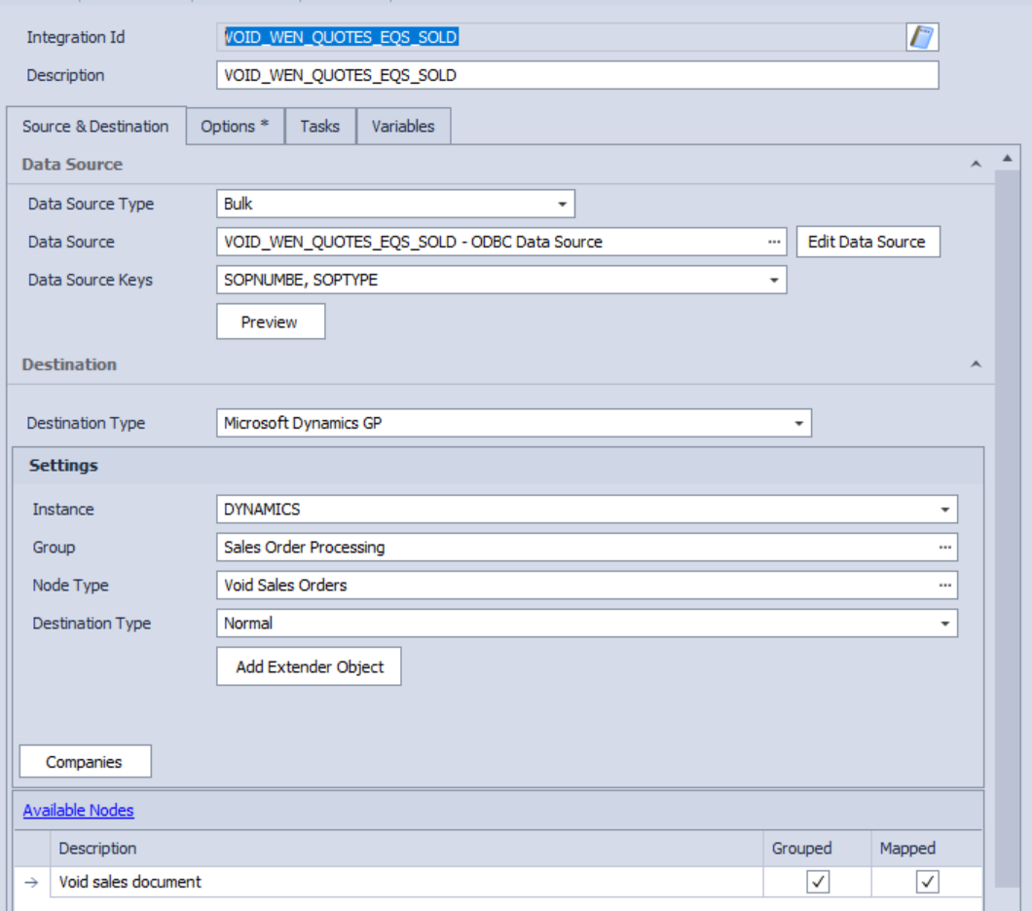

Schedule Configuration Screen

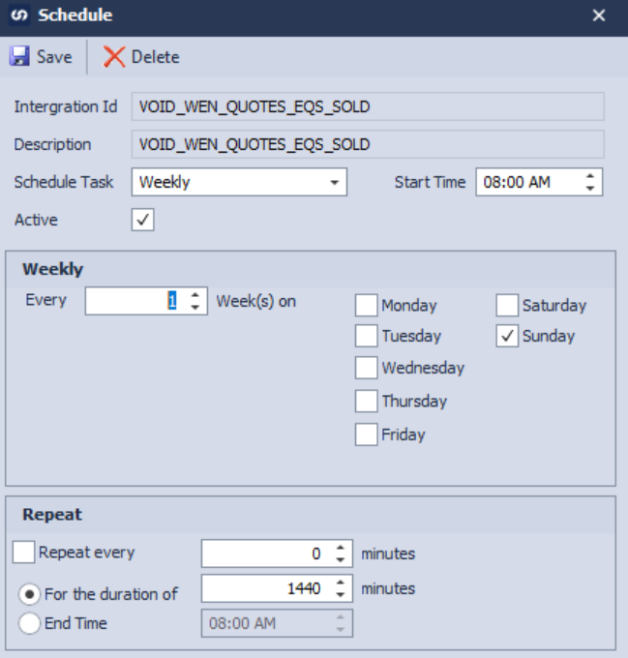

Service Account Configuration

Business Rules:
- Only quotes marked as Void/Cancelled in Wennsoft are eligible for synchronization to GP.
- A quote can only be voided if it has not been fully invoiced or financially closed in GP.
- Void transactions must reference a valid existing Quote Number in GP.
- All void actions must follow approved change management and authorization procedures.
- Once successfully voided in GP, the transaction status must be updated to prevent reprocessing.

Validation Rules:
At the database/server level, SQL and Windows may throw errors.

Code | Meaning
SQL 2627 | Duplicate key
SQL 547 | FK constraint
SQL Timeout | Performance issue
Login failed (18456) | Credential issue
Deadlock | Concurrency problem

Dependencies (Month-end / Period-end):
Billing processes dependent on quotes records must align with month-end processing schedules.

3.5.3 Technical Design

Integration Type (API / SSIS / SQL / File / Web Service):
File-based integration using Excel as the source with SmartConnect processing.

Middleware / Tool Used:
eOne SmartConnect.

Job Names / Package Names:
VOID_WEN_QUOTES_EQS_SOLD (SmartConnect Map).

Schedules & Triggers:
Configured in SmartConnect Scheduler – Daily execution at 08:00 AM.

Database Tables / Views Used:
Wennsoft Quote Tables
Authentication Method:
MS_GP connection configured. Encryption: Not enabled (Encrypt unchecked)
Encryption Method:
Encryption: Not enabled (Encrypt unchecked)

Logging Mechanism:
SmartConnect Execution History with error capture and record-level validation logging.

3.5.4 Data Flow & Field Mapping
Source Fields:
Entity | Description
SOPNUMBE | Sales document number
SOPTYPE | Sales document type
Below is the high-level reference mapping between Wennsoft and Microsoft Dynamics GP for VOID_WEN_QUOTES_EQS_SOLD:
Source System (Excel) | Source Field | Transformation Logic | Target System (MS_GP – Sales Order Processing) | Target Field | Mandatory (Y/N)
Excel (File Source) | SOPNUMBE | Direct mapping | Void Sales Order | SOPNUMBE | Y
Excel (File Source) | SOPTYPE | Direct mapping | Void Sales Order | SOPTYPE | Y

Transformation Logic:
VOID_WEN_QUOTES_EQS_SOLD data is directly transformed and transmitted from WennSoft to Microsoft Dynamics GP without any intermediate transformation
Target Fields:
Entity | Description
VOID_WEN_QUOTES_EQS_SOLD | Entity Id
SOPNUMBE | Sales document number
SOPTYPE | Sales document type

Mandatory vs Optional:
- SOPNUMBE– Required to identify sales document.
- SOPTYPE – Required to determine sales document type.
Reconciliation Rules:
Sales document types will be reconciled based on the sales document number.
Rule | Description
Item Validation | No impact on the existing data, it will create new entries.

3.5.5 Error Handling & Recovery

Category | Description | Example
Data Validation | Invalid or missing data | Item not found in GP
System | Infrastructure failures | SQL timeout
Integration | Job execution failure | SmartConnect map failed
Security | Access failure | Credential expired

Common Failure Scenarios:
- Quote status update fails due to data mismatch in the source system (Wennsoft).
- Integration run gets incomplete because of network or API connectivity issues.
- Process halts due to duplicate quote entries or missing mandatory fields.
- Scheduled job failures caused by timeouts or system overload.
System Exceptions:
- API call failures, such as HTTP errors (500, 404) during data fetch or push.
- Database connection errors in GP or Wennsoft systems.
- Timeout or latency issues during bulk data processing.
- Unauthorized access errors due to expired or invalid API credentials.
Business Exceptions:
- Update is rejected if the quote is already sold or voided.
- Invalid product or pricing mismatch between GP and Wennsoft.
- Missing approval workflow or mandatory fields (e.g., customer ID, quote ID).
- Violation of business rules, such as attempting to void quotes outside the allowed date range.
Retry Mechanism:
No automatic retry; failed records must be corrected and reprocessed manually in SmartConnect.
Manual Reprocessing Steps:
Re-run failed job after correcting data

Escalation Path:
Level | Responsible Team | Action
L1 | ERP Support | Review logs and reprocess
L2 | Integration Technical Owner | Investigate configuration issues
L3 | DBA / Infra | Resolve server or connectivity issues

Known Error Register
Need to work with Arthur and team

ID | Source | Priority | Error | Root Cause | Fix | Owner
KE-01 | SC |  | Item missing | Master sync gap | Create item | IT
KE-02 | GP |  | Invalid GL | Mapping error | Update mapping | Finance

Sample Logs
Logging is enabled for this integration in SmartConnect, and it includes three types of logs: Error Logs, Source Data Error Logs, and Success Logs.

3.5.6 Knowledge Management

FAQs (Frequently Asked Questions)
Q1: What happens if a quote that is already sold is attempted to be voided?
The integration will reject the operation and log a business exception, as voiding sold quotes is not allowed.
Q2: How can I know if the integration job has failed due to system errors?
System exceptions like API failures, database connection errors, or timeouts will be logged in the integration run logs with error codes for troubleshooting.
Q3: Can missing fields in the source system cause the integration to fail?
Yes, missing mandatory fields like Customer ID or Quote ID will halt the process and generate a business exception that needs to be corrected before re-running.

Known Limitations
- Integration cannot process quotes that have incomplete or missing mandatory fields; manual correction may be required.
- Voiding sold quotes outside the allowed date range is not supported.
- Bulk processing may experience delays during high-volume runs due to system performance limits.

Lessons Learned
- Always validate source system data before triggering the integration to avoid unnecessary failures.
- Scheduled job monitoring is critical to quickly detect API or network failures.
- Logging both system and business exceptions helps in faster troubleshooting and reduces downtime.

Historical Incident Summary

Shadowing Observations
- Observing live integration runs helps identify edge cases like duplicate quotes or data mismatches.
- Shadowing during error scenarios improves understanding of exception handling and corrective actions.
- Provides insights into the impact of business rules on integration success, such as voiding restrictions.

3.5.7 Continuous Service Improvement (CSI)

Improvement Opportunities Identified
- Enhance data validation at the source system to reduce failures due to missing or incorrect fields.
- Optimize the integration logic to handle bulk quote processing more efficiently.
- Improve error reporting with detailed messages to quickly identify root causes.

Automation Opportunities
- Automate the detection and correction of missing mandatory fields before integration runs.
- Schedule automated retry for failed jobs due to transient system or network issues.
- Implement automated notifications for business exceptions to reduce manual intervention.

Monitoring Enhancements
- Implement real-time dashboards to monitor integration job status and exception counts.
- Set up alerting mechanisms for system and business exceptions to ensure faster resolution.
- Track performance metrics such as processing time per quote to identify bottlenecks.

Risk Reduction Plan
Identified Risk | Mitigation Action
Duplicate Agreement creation | Enforce uniqueness validation before commit
Missing master data dependency | Pre-validation against GP master tables
Risk Review Frequency: Quarterly

Integration Health Scorecard
KPI | Target | Current Status
Integration Success Rate | > 99% | [To Be Confirmed]
Average Incident Resolution Time | Within SLA | [To Be Confirmed]
Recurring Incident Count | Decreasing Trend | [To Be Confirmed]
Scorecard Owner:
ERP / Integration Manager

3.6 WS Branches Integration

3.6.1 Integration Identification
- Integration Name: WS_BRANCHES
- Source System: Microsoft Excel
- Target System: Microsoft Dynamics GP
- Direction (Inbound / Outbound / Bi-directional): Inbound (Excel → Dynamics GP)
- System of Record: Wennsoft
- Business Owner: Aidacare Service/Fleet Management
- Technical Owner: Arthur Achilleos
- Criticality: High

3.6.2 Functional Description

Business Purpose:
To automate the creation and maintenance of Branch records within WennSoft (Key2Act) Equipment Management by importing structured branch data into Microsoft Dynamics GP, ensuring accurate organizational alignment, reducing manual configuration, and supporting rental, service, and financial transaction processing across multiple locations.

Trigger Event:
Scheduled execution via SmartConnect (Daily schedule configured at 08:00 AM).

Frequency:
Daily (Every 1 day).

Job Configuration Screenshots

Integration Script Configuration
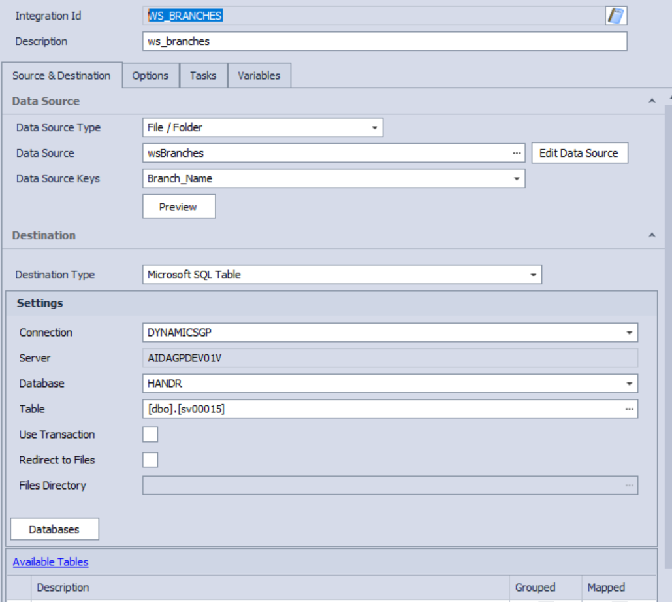

Schedule Configuration Screen

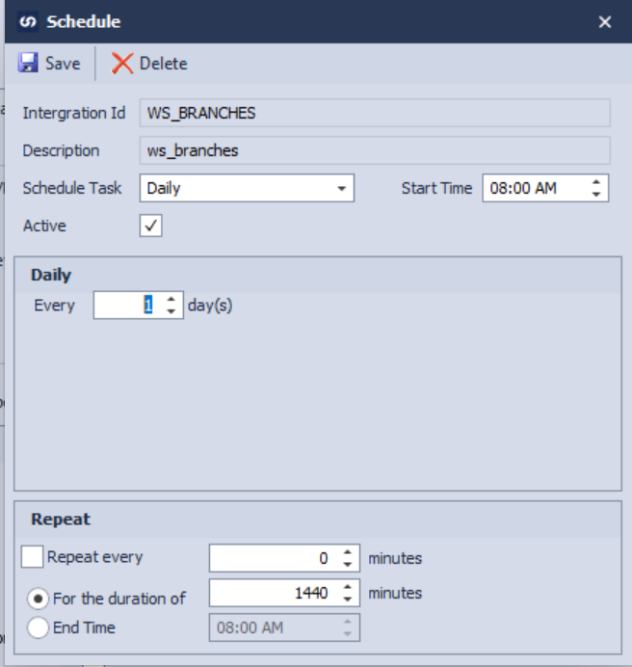

Service Account Configuration

3.6.3 Technical Design

Integration Type (API / SSIS / SQL / File / Web Service):
File-based integration using Excel as the source with SmartConnect processing.

Middleware / Tool Used:
eOne SmartConnect.

Job Names / Package Names:
WS_BRANCHES (SmartConnect Map).

Schedules & Triggers:
Configured in SmartConnect Scheduler – Daily execution at 08:00 AM.

Database Tables / Views Used:
GP branches Tables
Authentication Method:
MS_GP connection configured. Encryption: Not enabled (Encrypt unchecked)
Encryption Method:
Encryption: Not enabled (Encrypt unchecked)

Logging Mechanism:
SmartConnect Execution History with error capture and record-level validation logging.

3.6.4 Data Flow & Field Mapping

Entity | Description
Time_Zone_Tag | Identifies the time zone associated with the branch location (e.g., EST, PST, UTC+10) and is used for scheduling, reporting, and transaction timing.
Wennsoft_Affiliate | Indicates whether the branch is associated with a specific affiliate entity within the organization. This may represent a Yes/No flag or an affiliate code..
Wennsoft_Branch | Represents the internal branch identifier defined within the WennSoft system and used for integration and operational processing.
Wennsoft_Region | Specifies the region code defined within WennSoft to group multiple branches under a regional structure.
State | Price template identifier used to group or define pricing logic.
Branch_Name | The full descriptive name of the branch used for display and reporting purposes.
Branch | The unique short branch code or identifier used within the ERP system.
Region | Defines the broader geographic or operational region to which the branch belongs.

Below is the high-level reference mapping between Wennsoft and Microsoft Dynamics GP for WS_BRANCHES :
Source System (Excel) | Source Field | Transformation Logic | Target System (MS_GP – Branch Node) | Target Field | Mandatory (Y/N)
Excel (File Source) | Branch | Direct mapping | MS_GP – Branch Setup | Branch ID | Y
Excel (File Source) | Branch_Name | Direct mapping | MS_GP – Branch Setup | Branch Name | Y
Excel (File Source) | Region | Direct mapping (validated against Region setup) | MS_GP – Branch Setup | Region ID | Y
Excel (File Source) | State | Direct mapping | MS_GP – Address Setup | State | N
Excel (File Source) | Time_Zone_Tag | Direct mapping (validated against system time zones) | MS_GP – Branch Setup | Time Zone | N
Excel (File Source) | Wennsoft_Region | Direct mapping | MS_GP – Wennsoft Extension | Wennsoft Region | Y
Excel (File Source) | Wennsoft_Branch | Direct mapping | MS_GP – Wennsoft Extension | Wennsoft Branch ID | Y
Excel (File Source) | Wennsoft_Affiliate | Direct mapping / Boolean conversion (Yes/No) | MS_GP – Wennsoft Extension | Affiliate Flag | N
Excel (File Source) | (Default / Static) | System-controlled | MS_GP – Branch Setup | UpdateIfExists | System Controlled

Transformation Logic:
WS_BRANCHES data is directly transformed and transmitted from WennSoft to Microsoft Dynamics GP without any intermediate transformation

Target Fields
Entity | Description
Branch ID | Unique identifier assigned to the branch in Microsoft Dynamics GP.
Branch Name | Full descriptive name of the branch used for reporting and display.
Region ID | Region to which the branch is assigned within GP.
State | State or province where the branch is located.
Time Zone | Time zone associated with the branch location.
Wennsoft Branch ID | Wennsoft-specific branch identifier mapped to GP.
Wennsoft Region | Wennsoft region linked to the branch in GP.
Affiliate Flag | Indicates whether the branch is associated with an affiliate entity (Yes/No).
UpdateIfExists | System-controlled flag that determines whether existing branch records are updated during integration.

Mandatory vs Optional:
Branch ID – Required as the unique branch identifier in Microsoft Dynamics GP.
Branch Name – Required to clearly identify the branch for operational and reporting purposes.
Region ID – Required to assign the branch to a valid operational region.
Wennsoft Branch ID – Required for Wennsoft system integration and mapping.
Wennsoft Region – Required to associate the branch with the correct Wennsoft regional structure.
Time Zone – Required to ensure accurate transaction timing and scheduling (if time-based processing is enabled).
State – Required where geographic or tax reporting validation is applicable.
Affiliate Flag – Required only if affiliate-based reporting or configuration is enabled.

Reconciliation Rules:
- Branch record count must match between Wennsoft (source file) and Microsoft Dynamics GP after synchronization.
- All successfully processed branch records must be created or updated in GP without discrepancy.
- Any rejected or failed branch records must be logged and reconciled before the next integration cycle.
- Branch ID values must match exactly between source (Excel) and target (GP).
- Region and Wennsoft mappings must be validated to ensure correct structural alignment in GP.

3.6.5 Error Handling & Recovery
Category | Description | Example
Data Validation | Invalid or missing data | Item not found in GP
System | Infrastructure failures | SQL timeout
Common Failure Scenarios:
- Missing mandatory fields (e.g., Branch ID, Region ID).
- Duplicate Branch ID detected in GP when UpdateIfExists is disabled.
- Invalid Region or Wennsoft Region mapping.
- Incorrect data format (e.g., invalid time zone or state code).
- SmartConnect map configuration errors.

System Exceptions:
- Database connectivity failure between SmartConnect and GP.
- GP service interruption during synchronization.
- SmartConnect job timeout or scheduler failure.
- SQL deadlock or database locking issues.
- Permission or authentication failure on MS_GP connection.

Business Exceptions:
- Branch record not approved for activation.
- Region not configured in GP master tables.
- Affiliate configuration mismatch.
Retry Mechanism:
No automatic retry; failed records must be corrected and reprocessed manually in SmartConnect.
Manual Reprocessing Steps:
Re-run failed job after correcting data

Escalation Path:
Level | Responsible Team | Action
L1 | ERP Support | Review logs and reprocess
L2 | Integration Technical Owner | Investigate configuration issues
L3 | DBA / Infra | Resolve server or connectivity issues

Known Error Register
Need to work with Arthur and team

ID | Source | Priority | Error | Root Cause | Fix | Owner
KE-01 | SC |  | Item missing | Master sync gap | Create item | IT
KE-02 | GP |  | Invalid GL | Mapping error | Update mapping | Finance

Sample Logs
Logging is currently not enabled for this integration in SmartConnect but can review the activity in the SmartConnect.

3.6.6 Knowledge Management

FAQs (Frequently Asked Questions)
1. What happens if a Branch ID already exists in GP?
If UpdateIfExists is enabled in SmartConnect, the existing record will be updated. Otherwise, the integration will fail due to duplicate validation.

2. What if the Region does not exist in GP?
The integration will fail. The Region must be created in GP master setup before running the WS_BRANCHES synchronization.

3. Is Time Zone mandatory for branch creation?
Time Zone is optional unless time-based processing or scheduling rules require it.

Lessons Learned
- Proper validation of mandatory fields (Branch ID, Region, Wennsoft mappings) prevents most integration failures.
- Standardizing data format (trim, uppercase) reduces duplicate and mismatch issues.
- Pre-validating master data in GP avoids synchronization errors.
- Clear change management approval is important before updating branch records.

Historical Incident Summary

Shadowing Observations
- Many failures occur due to incorrect or missing Region configuration in GP.
- Duplicate Branch IDs are a common issue when UpdateIfExists is disabled.
- Monitoring SmartConnect execution logs helps in quick issue resolution.
- Data formatting inconsistencies (spaces, case sensitivity) often cause avoidable errors

3.6.7 Continuous Service Improvement (CSI)

Improvement Opportunities Identified
- Implement automated pre-validation checks in the integration layer to identify missing master data (Region, Wennsoft Region, Organizational Structure) before processing.
- Introduce real-time error notifications and monitoring dashboard to proactively track failed Branch imports and reduce resolution time.

Automation Opportunities
- Configure automated email notifications on WS_BRANCHES integration failure.
- Implement pre-validation script to detect duplicate Branch IDs before import.
- Develop automated reconciliation report comparing source branch records vs created/updated records in GP.
Automation Tool (if planned): [To Be Confirmed]
- Implement automated integration job monitoring with success/failure status alerts via email notifications.
- Develop a centralized dashboard to track Branch creation volume, update frequency, error rates, and processing time trends.
- Enable detailed audit logging to capture branch changes, user activity, and timestamp history for traceability..
Monitoring Tool Used: [To Be Confirmed]

Risk Reduction Plan
Identified Risk | Mitigation Action
Duplicate Branch ID creation | Enforce uniqueness validation before record commit
Missing Region or Wennsoft mapping | Pre-validation against GP Region Master and Wennsoft setup tables
Incorrect organizational structure mapping | Validate Region and Branch hierarchy before processing
Risk Review Frequency: Quarterly

Integration Health Scorecard
KPI | Target | Current Status
Successful Branch Import Rate | ≥ 98% per integration run | Within acceptable range
Average Processing Time per Batch | < 5 minutes per batch | Stable
Error Resolution Time | < 1 business day | Monitored
Duplicate / Rejected Record Rate | ≤ 2% per run | Under review
Scorecard Owner:
ERP / Integration Manager

3.7 WennSoft Models Integration

3.7.1 Integration Identification
- Integration Name: WENNSOFTMODELS
- Source System: Microsoft Excel (File / Folder – Excel 2010 Data Source)
- Target System: Microsoft Dynamics GP (WennSoft / Key2Act – Equipment Management)
- Direction (Inbound / Outbound / Bi-directional): Inbound (Excel → Dynamics GP)
- System of Record: Wennsoft
- Business Owner: Aidacare Service/Fleet Management
- Technical Owner: Arthur Achilleos
- Criticality: High

3.7.2 Functional Description

Business Purpose:
To automate the creation and maintenance of WennSoft Model records within WennSoft (Key2Act) Equipment Management by importing structured model data from Excel into Microsoft Dynamics GP, ensuring standardized equipment setup, reducing manual configuration, and supporting accurate rental, service, and asset management processes.

Trigger Event:

Scheduled execution via SmartConnect (Daily schedule configured at 08:00 AM).

Frequency:

Daily (Every 1 day).

Job Configuration Screenshots

Integration Script Configuration

Schedule Configuration Screen

Service Account Configuration

Business Rules:
- Model ID must be unique within the system.
- Item Number must exist in the GP Item Master.
- Pricing and Rate Structure must be defined.
- Equipment Class must be valid.
- Depreciation and Asset Settings must be configured.
- Header record validation must complete successfully.

Validation Rules:
- Mandatory fields must not be blank (e.g., Model ID, Description, Item Number, Equipment Class).
- Model ID must be unique and must not already exist in the EMS Model Master table.
- Item Number must exist and be active in the GP Item Master.
- Equipment Class, Branch, and Division must be valid within the organizational structure.
- Numeric and date fields must contain valid values and follow system-defined formats.
At the database/server level, SQL and Windows may throw errors.
Code | Meaning
SQL 2627 | Duplicate key
SQL 547 | FK constraint
SQL Timeout | Performance issue
Login failed (18456) | Credential issue
Deadlock | Concurrency problem

Dependencies (Month-end / Period-end):
Agreement creation should not occur in closed financial periods.
Billing processes dependent on agreement records must align with month-end processing schedules.

3.7.3 Technical Design

Integration Type (API / SSIS / SQL / File / Web Service):
File-based integration using Excel as the source with SmartConnect processing.

Middleware / Tool Used:
eOne SmartConnect.

Job Names / Package Names:
WENNSOFTMODELS (SmartConnect Map).

Schedules & Triggers:
Configured in SmartConnect Scheduler – Daily execution at 08:00 AM.

Database Tables / Views Used:
GP Models Tables
Authentication Method:
MS_GP connection configured. Encryption: Not enabled (Encrypt unchecked)
Encryption Method:
Encryption: Not enabled (Encrypt unchecked)

Logging Mechanism:
SmartConnect Execution History with error capture and record-level validation logging.

3.7.4 Data Flow & Field Mapping
(Not able to connect to the SmartConnect mappings)

3.7.5 Error Handling & Recovery
Category | Description | Example
Data Validation | Invalid or missing data | Item not found in GP
System | Infrastructure failures | SQL timeout
Integration | Job execution failure | SmartConnect map failed
Security | Access failure | Credential expired

Common Failure Scenarios:
- Duplicate Model ID already existing in the EMS Model Master table.
- Missing or invalid Item Number that does not exist in the GP Item Master.
- Invalid or missing mandatory fields (Model ID / Description / Equipment Class / Branch).
- Invalid Equipment Class, Branch, or Division not configured in WennSoft or GP setup.

System Exceptions:
- Database connection failure between integration tool and Microsoft Dynamics GP / WennSoft system.
- Transaction rollback triggered due to validation failure or unexpected system interruption.
- Permission or security exception where the integration service account does not have rights to create or update Model records.
Business Exceptions:
- Model cannot be activated because required pricing or rate structure is not configured.
- Model creation rejected due to invalid or unmapped Equipment Class as per business classification rules.
- Model setup does not align with defined organizational policies (e.g., incorrect Branch/Division assignment).
Retry Mechanism:
No automatic retry; failed records must be corrected and reprocessed manually in SmartConnect.
Manual Reprocessing Steps:
Re-run failed job after correcting data

Escalation Path:

Level | Responsible Team | Action
L1 | ERP Support | Review logs and reprocess
L2 | Integration Technical Owner | Investigate configuration issues
L3 | DBA / Infra | Resolve server or connectivity issues

Known Error Register
Need to work with Arthur and team

ID | Source | Priority | Error | Root Cause | Fix | Owner
KE-01 | SC |  | Item missing | Master sync gap | Create item | IT
KE-02 | GP |  | Invalid GL | Mapping error | Update mapping | Finance

Sample Logs
Logging is currently not enabled for this integration in SmartConnect but can review the activity in the SmartConnect.

3.7.6 Knowledge Management

FAQs (Frequently Asked Questions)
1. What happens if a Model ID already exists in the system?
The integration will reject the record and log an error indicating a duplicate Model ID. No update will occur unless explicitly configured for update mode.

2. Can existing Models be updated through this integration?
Yes, provided the integration is configured for update functionality and the Model ID already exists in the system.

3. What occurs if the Item Number does not exist in GP?
The record will fail validation, and the Model will not be created until a valid Item Number is available in the GP Item Master.

Known Limitations
- Integration depends on valid Customer, Branch, and Division setup in GP.
- No automatic retry for failed agreement records.
- Real-time processing is not supported; execution is schedule-based.

Lessons Learned
- Pre-validation of source data reduces rejection rates.
- Ensuring master data availability (Customer/Branch) prevents downstream errors.
- Clear ownership between Business and IT improves resolution time.

- Documented Post-Incident Learnings:
[To Be Confirmed]

Historical Incident Summary

Shadowing Observations
- Integration execution steps documented.
- Field mapping maintained in Appendix.
- Troubleshooting steps available for common failures.
Shadowing Status:
[To Be Confirmed – Completed / In Progress]
Backup Resource Identified:
[To Be Confirmed]

3.7.7 Continuous Service Improvement (CSI)

Improvement Opportunities Identified
- Implement automated pre-validation checks in the integration layer to identify missing master data (Item, Equipment Class, Branch) before processing.
- Introduce real-time error notification and monitoring dashboard to proactively track failed Model imports and reduce resolution time.
- Enhance data governance by standardizing Model naming conventions and enforcing structured templates for source Excel uploads.

Automation Opportunities
- Configure automated email notifications on integration failure.
- Implement pre-validation script to detect duplicate Agreement Numbers before import.
- Develop automated reconciliation report comparing source vs created agreements.
Automation Tool (if planned): [To Be Confirmed]

Monitoring Enhancements
- Implement automated integration job monitoring with success/failure status alerts via email notifications.
- Develop a centralized dashboard to track Model creation volume, error rates, and processing time trends.
- Enable detailed audit logging to capture user activity, data changes, and timestamp history for compliance and traceability.
- Configure threshold-based alerts to identify repeated failures or abnormal spikes in rejected Model records.

Monitoring Tool Used: [To Be Confirmed]

Risk Reduction Plan
Identified Risk | Mitigation Action
Duplicate Model ID creation | Enforce uniqueness validation before record commit
Missing Item or Equipment Class master data | Pre-validation against GP Item Master and WennSoft setup tables
Incorrect Branch or Division mapping | Validate organizational structure before processing
Integration job failure during execution | Scheduled monitoring with automated alert notification
Risk Review Frequency: Quarterly

Integration Health Scorecard
KPI | Target | Current Status
Successful Model Import Rate | ≥ 98% per integration run | Within acceptable range
Average Processing Time per Batch | < 5 minutes per batch | Stable
Error Resolution Time | < 1 business day | Monitored
Duplicate / Rejected Record Rate | ≤ 2% per run | Under review
Scorecard Owner:
ERP / Integration Manager

3.8 EXCEL_WENNSOFT_MODELS Integration

3.8.1 Integration Identification
- Integration Name: EXCEL_WENNSOFT_MODELS
- Source System: Microsoft Excel
- Target System: Microsoft Dynamics GP
- Direction (Inbound / Outbound / Bi-directional): Inbound (Excel → Dynamics GP)
- System of Record: Wennsoft
- Business Owner: Aidacare Service/Fleet Management
- Technical Owner: Arthur Achilleos
- Criticality: High

3.8.2 Functional Description

Business Purpose:
The purpose of the EXCEL_WENNSOFT_MODELS integration is to automatically import model data from Excel into Microsoft Dynamics GP under the WennSoft Equipment Management (EMS Equipment node). This eliminates manual data entry, reduces errors, and ensures accurate and standardized equipment model records are maintained in the system.

Trigger Event:
Scheduled execution via SmartConnect (Daily schedule configured at 08:00 AM).

Frequency:
Daily (Every 1 day).

Job Configuration Screenshots

Integration Script Configuration
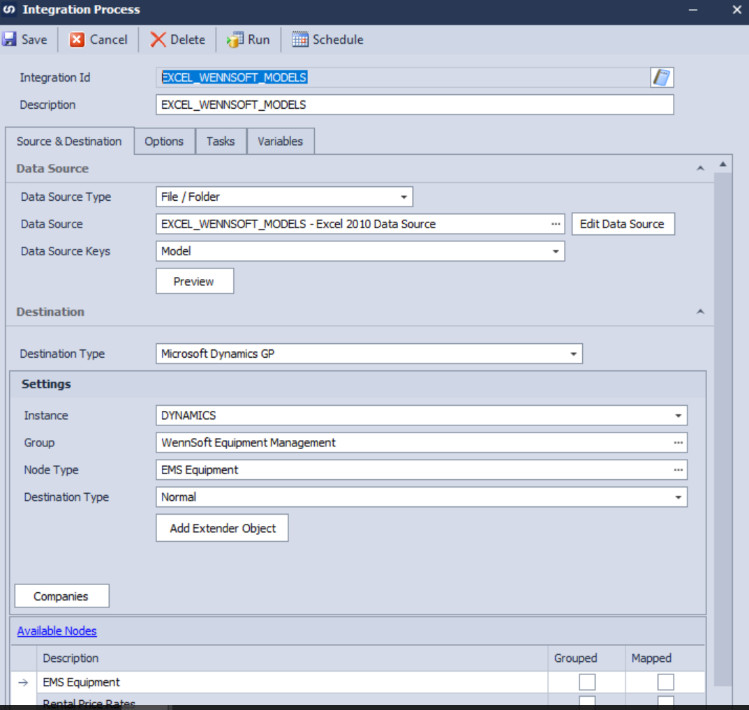

Schedule Configuration Screen

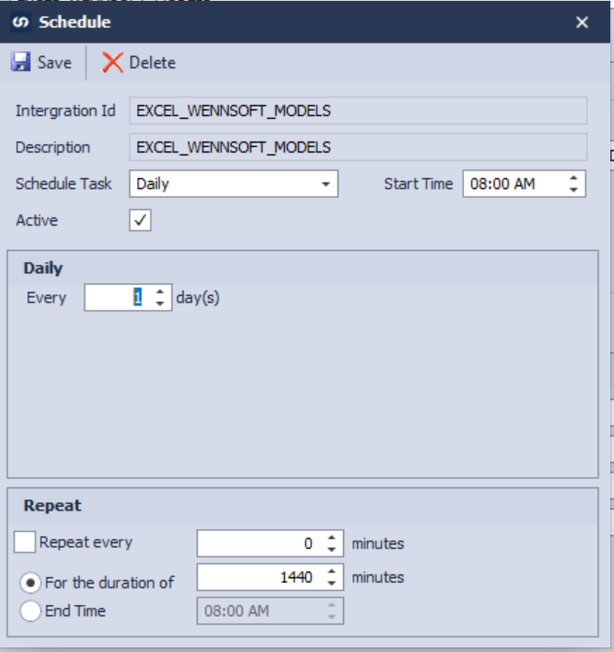

Service Account Configuration

3.8.3 Technical Design

Integration Type (API / SSIS / SQL / File / Web Service):
File-based integration using Excel as the source with SmartConnect processing.

Middleware / Tool Used:
eOne SmartConnect.

Job Names / Package Names:
EXCEL_WENNSOFT_MODELS (SmartConnect Map).

Schedules & Triggers:
Configured in SmartConnect Scheduler – Daily execution at 08:00 AM.

Database Tables / Views Used:
GP Models tables
Authentication Method:
MS_GP connection configured. Encryption: Not enabled (Encrypt unchecked)
Encryption Method:
Encryption: Not enabled (Encrypt unchecked)

Logging Mechanism:
SmartConnect Execution History with error capture and record-level validation logging.

3.8.4 Data Flow & Field Mapping

Below is the high-level reference mapping between Wennsoft and Microsoft Dynamics GP for wennsoft models:
Source System (Excel) | Source Field | Transformation Logic | Target System (MS_GP – EXCEL_WENNSOFT_MODELS) | Target Field | Mandatory (Y/N)
Excel (File Source) | Model | Direct mapping | MS GP | EQSEQUIPMODEL | Y
Excel (File Source) | ShortDescription | Direct mapping | MS GP | EQSA0005_DSCRIPTN | Y
Excel (File Source) | LongDescription | Direct mapping | MS GP | EQSA0005_EQS_Long_Description | Y
Excel (File Source) | (Default / Static) | System-controlled | MS GP | UpdateIfExists

Transformation Logic:.
EXCEL_WENNSOFT_MODELS data is directly transformed and transmitted from WennSoft to Microsoft Dynamics GP without any intermediate transformation

Target Fields

Entity | Description
EQSEQUIPMODEL | EQS equipment model number
EQSA0005_DSCRIPTN | Description of EQS equipment model.
EQSA0005_EQS_Long_Description | Detail description of EQS equipment model.
UpdateIfExists | System-controlled flag that determines whether existing branch records are updated during integration.

Mandatory vs Optional:
EQSEQUIPMODEL – Required.
EQSA0005_DSCRIPTN – Required
EQSA0005_EQS_Long_Description – Required.

Reconciliation Rules:
- EQS equipment details will be reconciled based on the model number.
- All successfully processed models must be created or updated in GP without discrepancy.
- Model number values must match exactly between source (Excel) and target (GP).

3.8.5 Error Handling & Recovery

Category | Description | Example
Data Validation | Invalid or missing data | Item not found in GP
System | Infrastructure failures | SQL timeout
Integration | Job execution failure | SmartConnect map failed
Security | Access failure | Credential expired

Common Failure Scenarios:
- Model data import fails due to missing or incorrectly formatted Excel files.
- Network or API connectivity issues prevent the integration from completing.
- Duplicate model entries or missing mandatory fields cause the process to halt..

System Exceptions:
- API call failures with HTTP errors (e.g., 500, 404) during data fetch or push.
- Database connection errors in GP or Wennsoft system during model updates.
- Timeout or latency issues while processing large Excel files.
- Unauthorized access errors if API credentials are expired or invalid.

Business Exceptions:
- Model already exists or inactive models are attempted to be updated, causing rejection.
- Invalid product, pricing, or category mapping between GP and Wennsoft.
- Missing approval workflow or mandatory fields (like Model ID, Product Code).
- Business rule violations, such as updating models outside allowed configurations or date range.
Retry Mechanism:
No automatic retry; failed records must be corrected and reprocessed manually in SmartConnect.
Manual Reprocessing Steps:
Re-run failed job after correcting data

Escalation Path:
Level | Responsible Team | Action
L1 | ERP Support | Review logs and reprocess
L2 | Integration Technical Owner | Investigate configuration issues
L3 | DBA / Infra | Resolve server or connectivity issues

Known Error Register
Need to work with Arthur and team

ID | Source | Priority | Error | Root Cause | Fix | Owner
KE-01 | SC |  | Item missing | Master sync gap | Create item | IT
KE-02 | GP |  | Invalid GL | Mapping error | Update mapping | Finance

Sample Logs
Logging is currently not enabled for this integration in SmartConnect but can review the activity in the SmartConnect.

3.8.6 Knowledge Management

FAQs (Frequently Asked Questions)
Q1: What happens if the Excel file contains duplicate models?
The integration will reject duplicate entries and log a business exception. Only unique models will be processed.
Q2: How can I verify if the integration job failed due to system errors?
System exceptions like API failures, database connection errors, or timeouts are logged in the integration run logs with specific error codes for troubleshooting.
Q3: What if mandatory fields like Model ID or Product Code are missing in the Excel file?
The process will halt, generating a business exception. Missing fields must be corrected in the source file before re-running the integration.

Lessons Learned
- Always validate the Excel source file for missing or incorrectly formatted fields before triggering the integration.
- Logging both system and business exceptions improves troubleshooting efficiency.
- Duplicate or inconsistent model data should be detected and resolved at the source to reduce failures

Historical Incident Summary

Shadowing Observations
- Observing live integration runs helps identify edge cases like duplicate models or mapping mismatches.
- Shadowing error scenarios improves understanding of exception handling and corrective actions.
- Provides insight into how business rules (like allowed model categories or status) affect integration success.
- Helps in understanding performance bottlenecks when processing large Excel files.

3.8.7 Continuous Service Improvement (CSI)

Improvement Opportunities Identified
- Enhance Excel file validation to automatically detect missing or incorrectly formatted fields before integration.
- Optimize integration logic to handle large Excel files more efficiently and reduce processing time.
- Improve error reporting with clear messages to quickly identify the root cause of failures.
- Implement pre-checks for duplicate models to prevent business exceptions.

Automation Opportunities
- Automate validation of Excel files for mandatory fields and correct formats before triggering the integration.
- Implement automated retries for failed jobs due to transient network or system issues.
- Set up automated notifications for business exceptions to reduce manual intervention.
- Enable auto-logging of exceptions with detailed context for faster troubleshooting.

Risk Reduction Plan
Identified Risk | Mitigation Action
Duplicate model creation | Enforce uniqueness validation before commit
Missing master data dependency | Pre-validation against GP master tables
Risk Review Frequency: Quarterly

Integration Health Scorecard
KPI | Target | Current Status
Integration Success Rate | > 99% | [To Be Confirmed]
Average Incident Resolution Time | Within SLA | [To Be Confirmed]
Recurring Incident Count | Decreasing Trend | [To Be Confirmed]
Scorecard Owner:
ERP / Integration Manager

